Yellow Class 2024/2025 | Autumn 1  (6 weeks and 4 days) | Autumn 2  (7 weeks and 3 days) | Spring 1  (6 weeks) | Spring 2  (6 weeks) | Summer 1  (4 weeks and 3 days) | Summer 2  (6 weeks and 1 day)
Literacy | Literacy unit  This is Me!  Bridging Unit- Harry the Happy Mouse  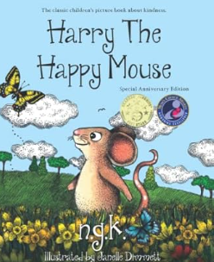 | Literacy unit  All around the world  Lost and Found  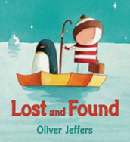 | Literacy unit  Amazing Animals  The Highway Rat  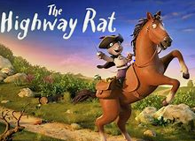 | Literacy unit  Growth and Green Fingers  Peter Rabbit  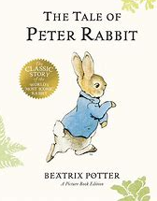 | Literacy unit  The Great Outdoors  Boris Goes Camping  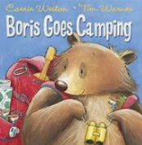 | Literacy unit  Journeys  How to Train a Train  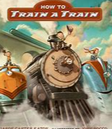
Phonics  Guided reading | Read, Write, Inc | Read, Write, Inc | Read, Write, Inc | Read, Write, Inc | Read, Write, Inc | Read, Write, Inc
Maths | - Number and place value  - Length and mass/weight  - Addition and subtraction  2D and 3D shape | - Sequencing and sorting  - Fractions  - Capacity and volume  - Money  - Time  Assess and review | - Number and place value  - Mass and weight  - 2D and 3D shape  - Counting and money  - Multiplication  Division | - Length, mass and weight  - Addition and subtraction  - Capicity and voumne  - Fractions  - Position and direction and time  2D and 3D shape Assess and Review | - Number and plcae value  - Addition and subtraction  - Capacity and volume  - Fractions  - Position and direction  - Time  2D and 3D shape | - Time  - Multiplication and division  - Statistics and calculation  - Measurement  - Sorting and sequencing  Assess and review
Science | Human body and the senses | Common animals other than humans and their basic structure | Common animals other than humans and their basic structure  Safari Phil Visit | Materials | Materials | Plants
Science | Seasonal change throughout the year
Topic | History  Changes within living memory  (Old and New Toys)  How have toys changed since the Victorians? | History  Events beyond living memory  (Great Fire of London)  Why did the fire spread so quickly?  Trip to Fire Museum | Geography  Fieldwork  My School and School Grounds  Local Area Walk  Weather and Climate: Identify seasonal and daily weather patterns throughout the  year | History  Homes then and now  How have houses changed since Victorian times? | Geography  London  Small Area of the UK  Weather and Climate: Identify seasonal and daily weather patterns throughout the year | Geography  Hot and cold places  Weather and Climate: Identify seasonal and daily weather patterns throughout the year
Computing | Internet Safety  Exploring Purple Mash  Grouping and Sorting | Internet Safety  Pictograms  Lego Builders | Internet Safety  Maze Explorers | Internet Safety  Animated Story Books | Internet Safety  Coding | Internet Safety  Spreadsheets  Technology outside school
RE | Harvest.  How can we help those who do not have a good harvest? | Christmas.  Why do we give and receive gifts?  Nativity Service | Jesus was special | Easter. Celebrating new life and new beginnings  Easter Service | Why is baptism special?  Church Visit | What do Christians believe God is like?
SEAL/PSHE | Living in the wider world |  | Relationships |  | Health and Well being
PE | Fundamental Movemement Skills - Catching  Fundamental Movemement Skills - Rolling | Fundamental Movemement Skills - Underarm throwing  Athletics | Gymnastics  Fundamental Movemement Skills – Selection of three skills | Fundamental Movement Skills - bouncing/catching  Gymnastics | Fundamental Movement Skills – Kicking  Outdoor Activities | Fundamental Movemement Skills – Overarm throwing  Athletics  Healthy Week
Art/DT | Art- Artist study: Andy Goldsworthy | DT – Mechanisms  Enterprise week | Art- Artist study: Paul Smith | DT- Structures | DT- Fruit Salad | DT- Fruit Salad  + Art week

